THE ROLE OF S⁰ PARTICLE SIZE IN BIOTIC AND ABIOTIC SULFUR CYCLING

A scope of instrumental analysis

Angel A. Garcia Jr.

- Particle Size Analysis
Particle Size Analysis (PSA) has been an important technique used to characterize particles in many areas of research, including soil sciences, geology, geomorphology, and engineering among others. For example, the determination of particle size distribution in order to catalog an streams is one the parameters that geomorphologists and ecologists have been using together to obtain better assessments of the quality of the streams which are necessary to ecosystem management (Splinter et al., 2010). Particle size is the important parameter to consider when we have the presence of suspended solids in water bodies, small sizes can suspend in the water column creating an environment with reduced light penetration, eutrophication, and poor water quality (Hatfield & Maher, 2009). In other fields like the construction industry, the particle size is the determining factor to ensure the quickness of drying and strength of the concrete (Holoubek, 2007). The range of particles size can be from micrometers to nanometers, but when the particle size is too small and the shapes are quite different, there are different instruments to monitoring the size using non-conventional techniques such as image analysis, sieves, and dry sieving among others (Wedd, 2005). Conventional techniques do not offer volume and size distribution of particles in the range of size from nanometers to micrometers (Wedd, 2005), many techniques were created in order to determine the particle size distribution.

1.1 Light Scattering
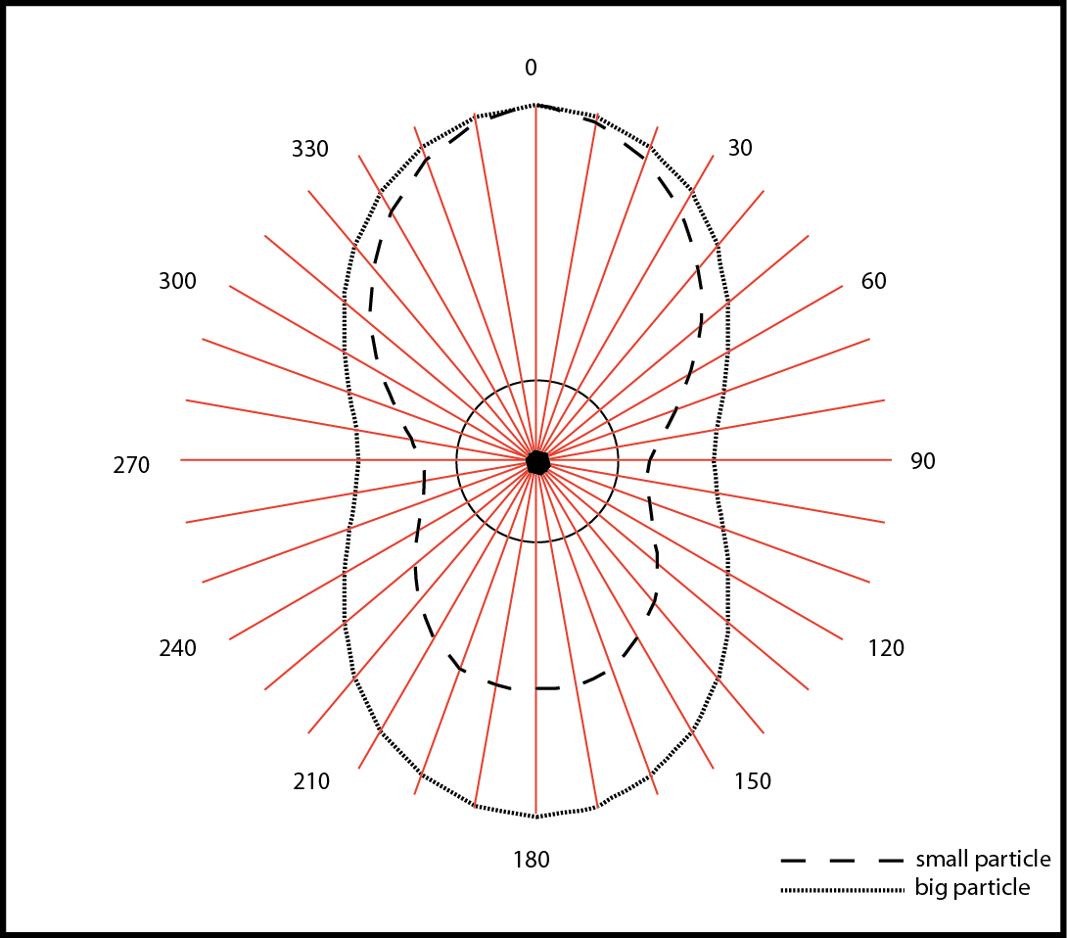
Lord Rayleigh provided the first theoretical application of light scattering for small, spherical, consistent-sized particles, which is now recognized as Rayleigh theory. This method is limited to particles smaller than the wavelength of visible light and sometimes the particles needs to be mono-shaped (Moore & Cerasoli, 2010). This is due to the fact that when a light beam hits a particle, the energy causes a distortion in the molecular electronic arrangement activating an oscillating molecular arrangement with dipole characteristics; light will scatter in all directions but the size of the particle will create some differences in how light is refracted from the center of the particle (figure 1). Is a fact that the size of the generated dipole is responsible for the intensity of scattered light, but depends of the polarizability of the particle, which is related to the molecular weight. Rayleigh scattering method can be utilized not for only size, but also for molecular weight of the particles just with the condition that the concentration and the refractive index of the homogenous sample is known. The refractive index (RI) increment index detectors are explained by the follow derivative:
Figure 1. Dipole generated by scattering light.
($\frac{dn}{dC})$
In which $dn$ is the slope of the differential refractive index against the concentration $\left(dC\right)$of the particle in the sample measured. The slope information in combination with the angular dependence of the intensity of the light scattered from the particle contributes to the size of the particle measured (Moore & Cerasoli, 2010).
Techniques like Laser Scattering (LS) have the ability to acquire size with high precision, allowing the distribution of particles to be described by a specific particle size population (Beckman Coulter Inc., 2010). The LS instruments are precise tools; this instruments consists in a non-invasive technique and does not require calibration before analysis. Once the lasers are located and referenced in a specific spatial coordinates (x,y,z) and synchronized with the scattered light sensors, the instruments does not need constant calibration as daily experimental procedure. When the laser is located in the specific coordinates, it has the capacity to move in different planes to acquire the better counts per second (CPS) of the particle population. In order to validate the performance of the instrument, the measurement of standards can reduce the experimental error. That is why is so important to have a full detailed description of how the samples were prepared for analysis, because this information will have an strong influence on how the size distribution will be determined and analyzed (Wedd, 2005; Pecora, 2000). Size distribution is so important in order to describe the differences, average, and prominent particles size of the sample, some authors already assume a relationship between the volume distribution with a specific size; which is expressed by the mathematical relation where the volume is proportional to the inverse of the cubed particle diameter$\left(\frac{1}{D^{3}}\right)$.
The idea of LS was introduced in the 70’s and at the present is one of the most accepted, used and reliable methods for characterizing a particle population by sizing (Wedd, 2005). Laser Scattering has been used for particle sizing from 0.05µm to 2000µm and the data is presented in volume that is equivalent to the diameter of the particle that has the same volume in the sample (Beckman Coulter Inc., 2010). The laser scattering instrument not only has the capacity to measure solid particles, but it can also measure other forms of particles suspended in liquid, such as dry powders, droplets, and molecular mass of some proteins and polymers (Holoubek, 2007).
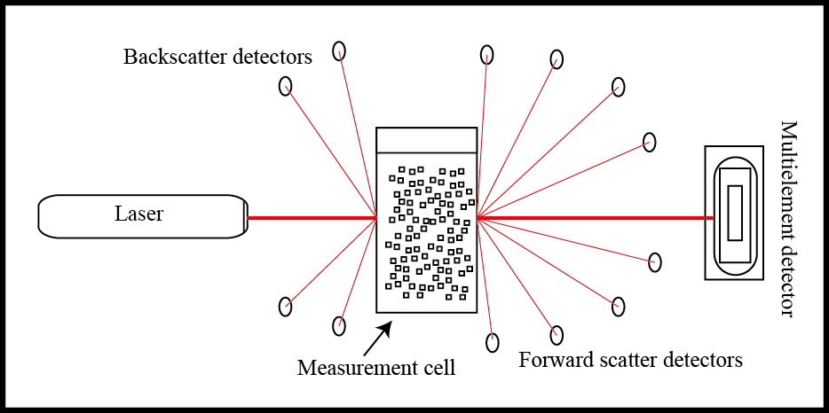
It is important to understand not only the output of the research instrument, but the theory behind each step of the particle sizing. The process starts (figure 2) when the laser beam passes through the measurement cell and end focused at the multi-element detector. The laser base has the capability to move inside the instruments at different planes in order to acquire measurements at different angles. The laser is required to obtain data from the scattering of the particles; therefore the more angles that are acquired, the more data that can be used to determine the size of the particle (Wedd, 2005). The laser beam can be polarized in order to facilitate measurements of the polarization dependence of the particle scattered light. The extinction and obscuration due to the presence of particle is also measured in order to estimate the volume distribution of the particle population.
Figure 2. Light scattering components and process.
All these specific characteristics are dependent on the size of the particle. Large particles can scatter more light at small angles in comparison with small particles that scatter light at greater angles. Every instrument have their own limitation, particle size analysis with laser scattering just applies to larger particles (0.05µm-2000µm), for smaller particles there are other techniques like Dynamic Light Scattering (DLS) which also includes a post-analysis of the particle size measurement in order to increase the precision of the experiment.

1.2 Dynamic Light Scattering
For submicrometer particle sizing there is a technique called Photon Correlation Spectroscopy (PCS), which is a technique used to determine the diffusion coefficient of a small population of particles suspended in fluid (Beckman Coulter Inc., 2010). Dynamic Light Scattering (DLS) as a set of techniques has the versatility for measuring size, determining size distribution, volume distribution, molecular weight (Beckman Coulter Inc., 2010) and in some cases determining the shape of the particles (Pecora, 2000).
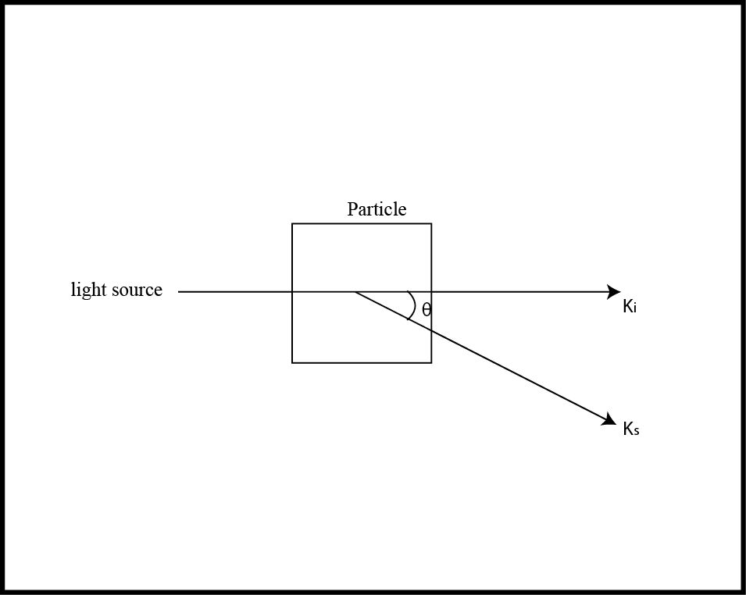
In order to perform Particle Size Analysis (PSA), the instruments need to have a specific concentration to be able to measure the particle size. The specific concentration will not depend on the volume concentration, but on the CPS value; CPS is the average size counted per second on the sample; which is measured by having suspended mono-sized particles diluted in a solution illuminated by a monochromatic coherent light source.
Figure 3. Refractive index (RI) from a particle.
Particles and the medium solution have a defined RI, which is a variant of every material and molecular structure (figure 3). This is explained by the relationship below:
$$k_{s}=\frac{4πn}{λ}sin\frac{θ}{2}$$
where $k_{s}$ is representing the vector of the light refracted from the particle, $n$ the RI of the medium where the particles are suspended, λ the wavelength of the source light, and θ the angle of observation from the light detectors. In this case the instrument has the assumption that the wavelength of the scattered light from every individual particle in the sample is identical to the incident light beam coming from the light source. It is also assumed that the amplitude of the incident light scattered from the particle is dependent upon its scattering cross-section and the difference in RI from the medium in which the particles are suspended. The scattered light from particles is acquired by a detector that accumulates the RI information for each particle and the medium with a combination of other parameters that will be explained later in the text. This detection is called a coherent detection because small particles are diffusing through the solution by the effect of the Brownian motion.
This “random walk” or Brownian motion is possible by the interaction between small particles and other components of the medium, meaning that the erratic motion of the small particles is a product of the collision between molecules and particles. In 1905 A. Einstein expressed his work as the mathematical relationship between molecular movement and diffusion in a liquid using the equation:
$$D=\frac{kT}{3πηx}$$
where $k$ is Boltzmann’s constant, $T$ the absolute temperature, and η the viscosity value of the medium used in the measurement. This is specifically designed for non-interacting spherical particles of nano-sized diameter. This limitation in the size is because if the particle has a greater size it will be influenced by gravity and Brownian motion will not applied, since the particles will settle down. As a consequence of the reflected light from the particles, speckles from different sizes appear at the viewing screen, which is composed of photon detectors with the capacity to open depending on the size of the speckle and to save that information from every single particle. The speckle size is defined by the wavelength of the light coming from the particle, the photon detector angle and the geometry of the incident light beam (Frisken, 2001). If the viewing screen is located at a definite distance from the measurement cell, which also is positioned in a specific angle from the incident beam, the photon detector pattern will be collected as a product of the interference between the scattered particle and the measurement cell.
This equation relates the diffusion coefficient with the hydrodynamic radius of the particles measured (Einstein, 1905; Frisken, 2001). The speckle pattern is constantly moving at a specific rate that is related to the rate of the particle speed, governed by diffusion. These measurements are correlating the rate of intensity change through time (Beckman Coulter Inc., 2010) and is defined by this equation:
$$G_{2}\left(τ\right)=[I\left(t\right).I\left(t+τ\right)]$$
The square brackets are representing the average value of the product$(I\left(t\right).I\left(t+τ\right))$; τ is a time difference dependent of the arbitrary time $t$ with intensity. Which in other words is the product of the function between intensity per time and how that intensity is changing through time at every measure, correlated by an arbitrary time.
That relationship works only for mono-sized particles with no interaction between each other meaning a sample with no imperfections. In real practice is possible to find a gamut of different sizes in the sample (Frisken, 2001). There is a technique that can post-correlate the data using other parameters like polydispersity index, volume distribution, and a mean particle size adopting the method of accumulation. For a polydisperse sample, the decaying function cannot be represented as a single exponential and require the representation as a summation (Frisken, 2001; Pecora, 2000) or indefinite integral of a distribution of decays rate:
$$\int_{0}^{∞}{G\left(Γ\right)dΓ}$$
This distribution function of the decays rates $G\left(Γ\right),$which could be a spectrum of continuous distributions. We can describe the function of decays rate as the function of the total mean intensity scattered by the particle as:
$$Dk^{2}=Γ$$
where $dΓ$ applies to particles were are measured. Koppel in 1972 expressed a possible solution for this nature of experiments. The data acquired should be supported with accumulation information. The method of accumulation has a base in statistical accumulation generation function about the particle size, intensity, and time. We can characterize the decay function from a series of combination of moments and accumulation times, just making a small adjustment in $\ln\left|g^{-1}(τ)\right|$from monomial to a polynomial.
The method of cumulants (Koppel, 1972) or better known as an accumulation time, is one of several ways that we can utilize the DLS data to have precision in the characterization of $G\left(Γ\right)$. Koppel described this method by the relation of some specific components; which includes first the $g^{\left(1\right)}\left(τ\right)$and the function of the moment-generating distribution; and between the logarithm of $g^{\left(1\right)}\left(τ\right)$ and the accumulation-generating function of distribution. It is important to take into consideration that when using the method of accumulation, except for the first every accumulation is invariant and taken as a reference of the origin. This gives the opportunity to write the accumulation times in term of moments about the mean as presented below:
$$\int_{0}^{∞}{G\left(Γ\right){(Γ-\overline{Γ})}^{m}dΓ}$$
The first accumulation time describes the average rate of decay function of distribution. The second and third accumulations belong to the appropriate moments about the mean. Due to this, the second accumulation time is not supposed to note any changes in size or any interaction between particles population. (Koppel, 1972; Frisken, 2001; Pecora, 2000). After the development of this method, the particle size analysis using scattered light became a powerful tool in order to understand and analyze the diffusion of nano-sized particles or macromolecules suspended in solution. The product of this method provides cogent information of the polydispersity in the particle population in the solution, making this method a simple routine to be incorporated in all data analysis.
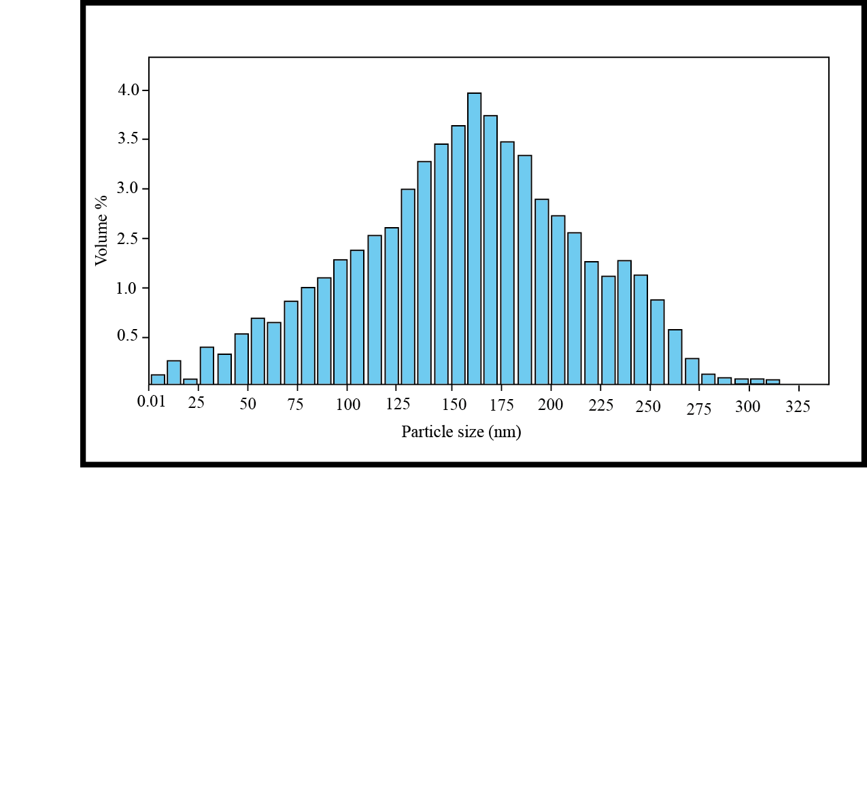
Dynamic light scattering is a technique that is reliable, fast, and a non-invasive analysis for particles of many materials. When analyzed, they can provide useful information (figure 4) as size, size distribution, volume distribution, polydispersity index, and molecular weight.
Figure 4. A representation of the volume % described from a particle population.

- X-ray Diffraction (XRD)
Crystallography is a vast science with many implications, whose origins precede the discovery of X-rays. A mineral can be defined as a solid structure of atoms, ions or molecules with a periodic pattern arrangement in three dimensions. In nature many solids posses a partial or periodic crystalline structure, but some compounds do not have that periodic arrangement and are considered polycrystalline (Dyar et al., 2008). That is why it is important to understand the forms and structures at the atomic level that make up those particles that can be seen with the naked eye. In 1895 a German physicist named Röntgen, after a series of experiments, discovered a significant difference between visible light and invisible light better known as X-rays. In his descriptions he established that X-rays traveled similar to visible light and also produced analogous behavior as the visible light in the photographic film (Dyar et al., 2008). After several more experiments he could appreciate how different each type of light really is. X-rays, have the capacity to penetrate deeper in objects than visible light and have the capacity to pass through the human body, wood, and an extensive list of objects.
In 1913 the physicists Braggs develop a relationship between the utilization of X-rays and crystals. Sir W.H. Bragg and his son W.L. Bragg explained with this relationship why the cleavage faces of crystals have the capacity to reflect X-rays where the beams have a specific θ angle of incidence (Brügermann & Gerndt, 2004). This observation opened a wide door of possibilities in the direct evidence for the periodic atomic structure of crystals, called the X-ray diffraction (XRD). This powerful technique can reveal the crystal structure of ${10}^{-7}$mm in size, which that precision is possible to explain some materials problems such as impurities in the crystalline structure.
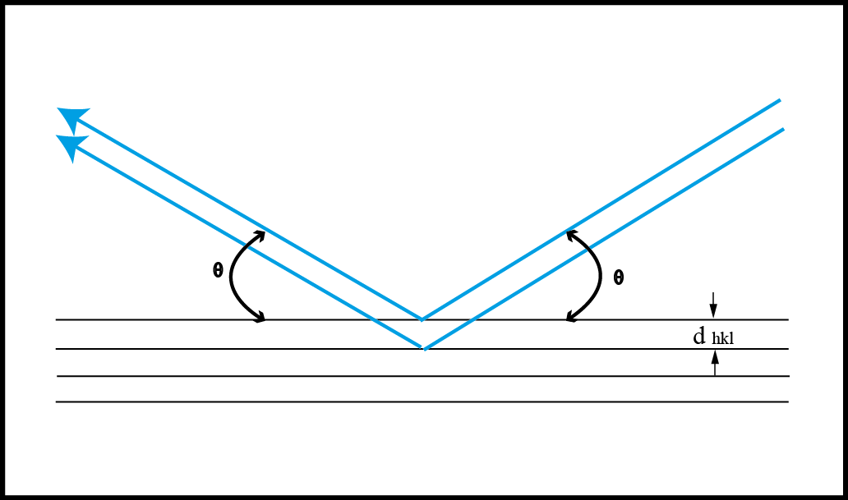
X-ray photons are used to analyze matter in analytical methods using an array in different instruments. This is possible because every element has a unique signature of X-ray behavior, in other words the energy of the emitted radiation is particular for each element (Brügermann & Gerndt, 2004). That distinct quality of every element is so precise that is possible to have detectors to measure very precisely and use them to determine the elemental composition of the analyzed sample. In X-ray diffraction, there is a part of the radiated X-ray beam that will scatter if its wavelength is equal or greater dimension as the inter-atomic distances present in the sample. An X-ray plunging on the atomic arrangement it will produce two kind of scattered radiation: Compton modified scattering of increased wavelength which is disoriented with respect to the primary beam, and no modified scattered which is oriented to the primary beam (Bertram & Lawrence, 2008). If X-rays strikes a target exhibiting long range order, diffraction occurs. Constructive and destructive interference effects results in X-rays only being emitted at characteristics angles (figure 5) (Cullity & Stock, 2001; Dicken et al., 2010). This relationship is well known and governed by Bragg’s law. There are two geometrical aspects that are important to have in consideration to explain the Bragg’s law: first, the incident X-ray beam, the diffraction plane, and the diffracted light beam are always coplanar. The Bragg’s law is possible to use because all crystals posses similar characteristics of how X-rays interact through the crystal’s structure $2θ$ (Dyar et al., 2008). This aspect of the behavior of X-rays is better known as diffraction angle, and this specific angle is measured experimentally and described by the Bragg’s law:
Figure 5. Inter-atomic distances conditions involved in Bragg's law.
$$λ=2dsinθ$$
where λ expresses the wavelength of radiation used, $d$ the spacing between the planes that are present in the atomic structure, and 2θ the angle through which the radiation is scattered. A detector located on a moving arm, circulates the sample with a constant radius collecting scattered radiation. In other words, XRD is used is used to explain the scattering of X-rays when there is an interference pattern in crystals. To identify the material the $d$ spacings are compared to a library of diffraction profiles to find the best match.

- Scanning Electron Microscopy (SEM)
Scanning Electron Microscopy (SEM) has the potential to image objects with high resolution at very small scales. In other words, SEM is used to magnify the surface of any object without destroying the sample. Detail of the sample is acquired by sequential images with a signal generated by an electron probe which scans the sample in a regular raster process which collecting every point and reference it in a grid the product is a 3D image.
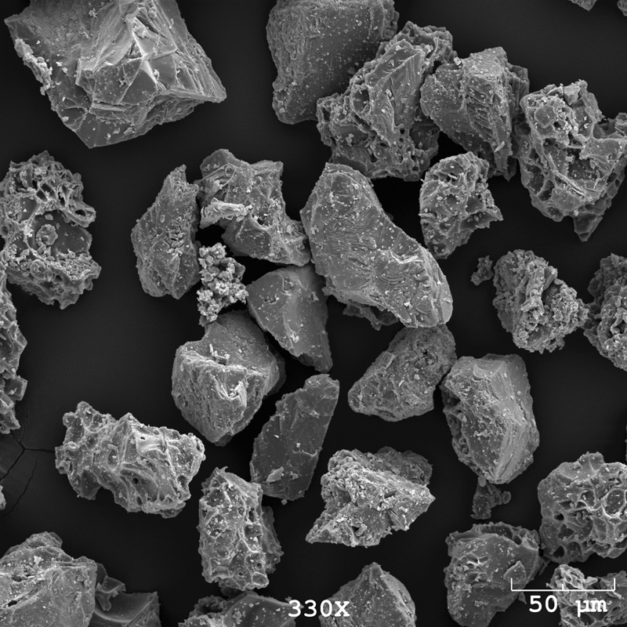
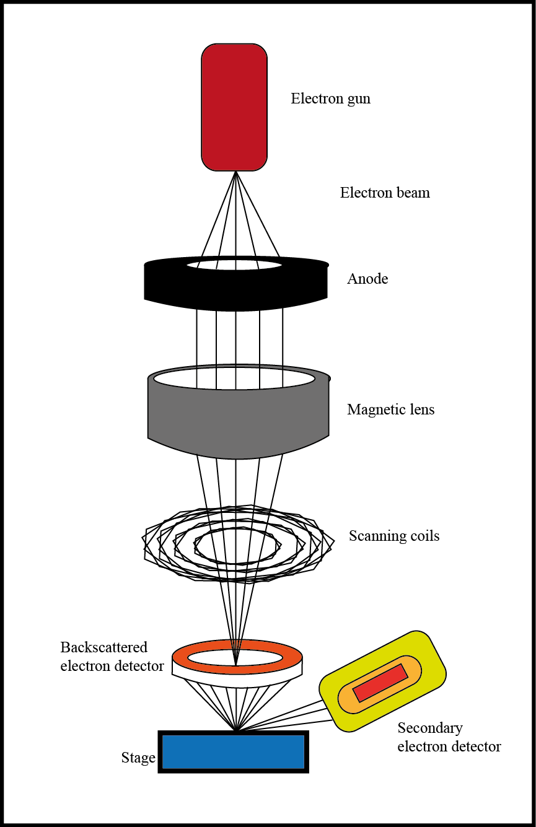
The scanning electron microscope has some advantages over other microscopes, like the light microscope and the transmission electron microscope (TEM). As an example the SEM have the significant quality to obtain images in three-dimensions, producing a real time image of how it looks with high resolution (image 1). On the other hand, micrographs produced by light or transmission electron microscopes are two-dimensional images, creating a limitation that the samples should be flat in thin sections (Black, 1974). Scanning electron microscope produces micrographs by scanning the surfaces with a beam of electrons in synchronization with the electron probe (Honjo & Berggren, 1967). Topographical variations in the objects allow a contrast to be seen by the microscope, which then allows for the production of a micrograph. The SEM is used in many fields because the limitation is only based on the preparation of the sample for the procedure. In order to understand how SEM works is necessary to understand the nature of electrons. These diminutive charged particles have a wavelength that is defined as a function of the inverse of their momentum ($\frac{1}{m∙v }$). This wavelength is very short with an approximation of less than 1Å at voltages used in the electron microscopy. Because the electrons are charged particles, is possible to accelerate it by bending the path, and can be focused. This innovative and high-resolution imagery instrument is developed by components (figure 6) like lens system, the electron gun, the electron collector and photo-recording cathode ray tube (CRT), and associated electronics in order to achieve the objective of zoom (Kimura et al., 1969). The electromagnetic condenser lenses, with energies of from 1 to 50$keV$, produce a narrow beam of electrons. The electrons are then accelerated, which is possible by the difference in voltage between the cathode and anodes (Reimer, 1998) into a small-diameter probe, creating a beam with the capacity to penetrate the surface (Hayes, 2008) and raster the surface of the object producing a micrograph. The energy released from the specimen is formed by a contribution from secondary electrons (SE). Secondary electrons are the result of inelastic collisions with the nucleus of the specimen resulting in the released of substantial energy (Reimer, 1998). Secondary electrons $(e_{2}-)$ have low energy, and can escape only from a thin layer. These secondary electrons are collected by an energy analyzer, and amplified and modulated into a light coordinate on the screen (Honjo & Berggren, 1967), providing high resolution imaging of fine surface morphology. In order to complete the process of scanning with the probe over the surface of the specimen, deflection coils need to be placed between the last two lenses to deflect the electron beam in a rectangular pattern over the object. Because of this synchronism between the scan generator and the deflection coils, there is a one-to-one correspondence between the position of the electron beam in the specimen and the spot on the raster image processor (Honjo & Berggren, 1967; Dyar et al., 2008). In other words, in order to created an SEM image the device needs to acquire the information from the interaction between electrons and sample surface. Electrons beams scans in a raster pattern across the sample surface. After the collision between the electrons and the surface, electrons are detected for each position in the scanned surface by an electron signal; these positions are displayed as brightness on a CRT (Todokoro & Ezumi, 1996; Kimura et al., 1969).
Image 1. Image of volcanic ash using Scanning Electron Microscope (SEM). Image from Alaska Volcano Observatory/University of Alaska Fairbanks Geophysical Institute.
Figure 6. Components of the Scanning Electron Microscope (SEM).

4. Raman spectroscopy
Raman scattering effect is one of the most famous and important discoveries in the last century. In 1928 the Indian scientist Chandrasekhara Venkata Raman established and proved the special relationship between bonds in molecules and their vibrations. This discovery became a truthfully analytical technique after and advent of the laser, requiring less sample to analyze and obtaining more precise results (Van Duyne & Haynes, 2004). After the revolutionary hypothesis that Albert Einstein proposed in 1905, which he established the light quanta, among other important findings, scientist like Max Planck called this a “speculation that missed the target”, but after Arthur Compton, who discovered the Compton effect, established the existence in a change in wavelength when an X-ray quantum hits an electron as a part of a collision process (Singh, 2002). The Compton effect is explained by the increase in wavelength of scattered electromagnetic radiation, which is determined by the angle of scattering. The scattering electron is assumed to be unbound and at rest, wavelength is increase approximation is possible by the following mathematical relationship:
$$Δλ=λ_{2}-λ_{1}=\frac{h}{m_{0}c}\left(1-\cos{ϕ}\right)$$
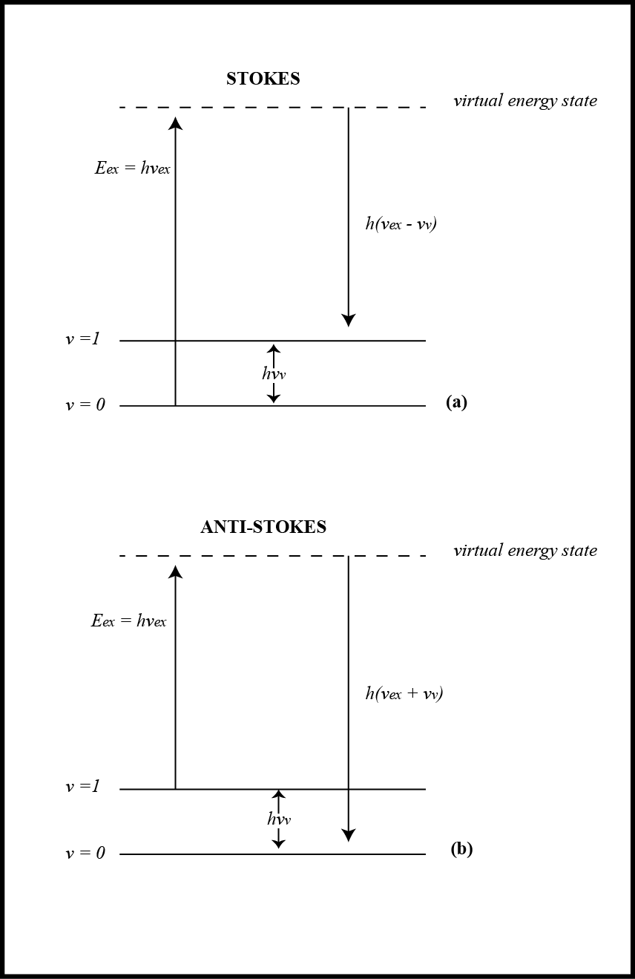
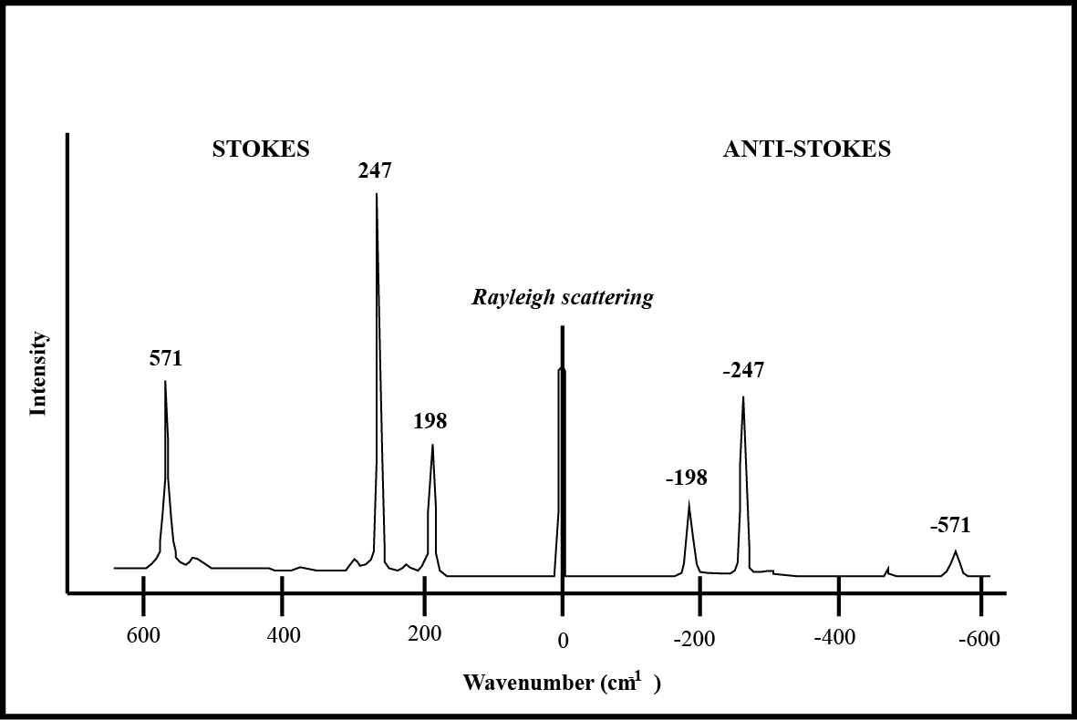
where λ₁ is representing the wavelength of the incident radiation, λ₂ is the wavelength of the radiation scattered at the angle ϕ, h is for the Plank’s constant, m₀ is the resulting mass of the electron, and c is for the speed of light. This impelled C.V. Raman to continue with more research about what the change in wavelength when light hits an electron in a molecule, this resulting in a major discovery. The product of his work was established that there is another effect of that kind of collision, the changing in wavelength of scattered monochromatic visible light. Molecules have an arrangement in which atoms are together by inter-atomical forces, bonds. The bonding force will vary depending the present atoms and how polarized is that arrangement to form a molecule. No matter what kind of bond is affecting the interatomic relationship, there is always been present an energy produced by this molecular arrangement. Also energy levels of a molecule are affected by rotational, electronic configuration, and vibrational process. A molecule in a ground vibrational state can absorb energy, as example photons with energy ${hv}_{ex}$ and emit back a photon with energy $h\left(v_{ex}-v_{v}\right)$. Raman spectroscopy can absorb that energy emitted back, without being affected by equal frequencies, or different. When the scattered radiation has low frequency in comparison with the initial, it is called stokes scattering (figure 7). When the radiation has a higher frequency it is called anti-stokes. Anti-stokes happen when the molecule is in an excited state $(v=1)$ the scattered radiation of order inestically will produce a Raman signal of energy $h\left(v_{ex}+v_{v}\right)$ (Skoog, Holler, & Crouch, Raman Spectroscopy, 2007), which represents that there is an exchange in energy after the collision photon-molecule, as a product a change in wavelength in the photon that is re-emitted (Van Duyne & Haynes, 2004), having in mind that the shifts of the inestically scattered radiation $\left(v_{ex}-v_{v}\right)-v_{ex}=-v_{v}$, corresponds to the vibrational frequency that the molecule has at the moment of the collision. Inelastically scattering are not the only kind of scattering, elastic scattering is also a product of this collision. Since inelastic collisions results in a scattered radiation at different frequency, making relatively large changes (shifts) in frequency (figure 8), which this characteristics are caused by the differences in energy related to the rotational and vibrational transitions in the molecule that the photon in colliding with; as an example this differences will result in a broadening of the peaks for elemental sulfur. That is the reason why we can appreciate the difference in intensity of Raman shifts, in wavenumbers (cm⁻¹), that is why these changes are a function to the absolute energy of the incident radiation. Elastic scattering occur when the energy emitted back is the same in comparison with the initial, in other words when the emitted photon has the same energy as the excited photon $\left({hv}_{ex}\right)$, or better known as Rayleigh scattering. This phenomenon is better explained as a result of the interaction between the light and the intermolecular arrangement, refractive index, and medium of the material (Moore & Cerasoli, 2010); where the light scatters with the same energy and frequency as the incident beam. Rayleigh irradiance is explained mathematically by describing the scattering of the light at any angle θ, (E_{sc})_{θ}:
Figure 7. Stokes and anti-stokes of Raman scattering
Figure 8. A representation of how is the vibrational shift represented as stokes, anti-stokes, and Rayleigh.
$${\left(E_{sc}\right)}_{θ}=\frac{8π^{4}{\left(α^{'}\right)}^{2}(1+\cos^{2}{θ})E_{0}}{λ^{4}d^{2}}$$
where α involves the particle’s volume polarizability, λ is the incident beam wavelength, θ is the existing angle between the incident light and the scattered radiation product of the refractive index, E₀ is the incident light irradiance, and d is distance that exist from the center of the scattering process to the detector which is perceiving light scattered. Rayleigh scattering has a significantly higher probability of occurring than Raman scattering, this is because there is a most probable transfer event that will happen between the collision photon-molecule. This event results from the emission from the collision, which has the same energy and frequency than the initial photon, when the molecule is in a vibrational ground state.
Raman spectroscopy can take advantage of the vibrational experienced between atoms in a molecule when light is impacted, in other words Raman technique uses the scattered light resulting from the collision of photon-molecule in order to describe molecular properties of the sample (Van Duyne & Haynes, 2004). It is important to highlight that in Raman the magnitude of the wavelength of the light that is used as a beam with the shifts is independent of the wavelength of excitation (Skoog, Holler, & Crouch, Raman Spectroscopy, 2007). This means that no matter the source or wavelength the light will always have inelastic and elastic collisions as a part of the encounter of photon-molecule.
As we know, no matter how we can consider the nature of light (classical or quantum-mechanical framework), light will scatter in different directions depending the molecular arrangement and the density of the material. Some of that light will pass thru the material and other quantity will scatter either inestically or elastically in different directions. Because light can be interpreted as two different behaviors of a wavelength and a package of energy, Raman established two different models to explain the phenomenon using classical model and quantum mechanical model of Raman scattering.
4.1.1 Classical model of Raman scattering
This model starts explaining the collision light-molecule by having in reference that the nature of the light in the wave forms. When a light wave meets a molecule, which consists of electrons and nuclei, there is an electric field of the wave that will remain constant at any instant that the light is traveling trough the molecule. This is because the molecule size is smaller than the size of the wavelength, in other words if we have a molecule of 1nm in size, this is small compared to the wavelength which typically is 500nm. Following this premise, the field will apply an equivalent force on all the electrons present in the molecule and will tend to displace them from their probability-averaged places around the nuclei, which is positively charged. Raman utilizes this model to explain that displacements of the electrons will result in a dipole moment $\left(μ_{ind}\right)$, in the molecule that is proportional to the electric field strength $E$. This proportion is explained by the following relationship:
$$μ_{ind}=αE$$
where α, represents a proportional factor, better known as the electric polarizability of the molecule. Dipole moment factor, ($μ_{ind}$) can be explained better as the factor which represents the distribution of the electrons in the molecule after the collision between light-molecule. The classical electromagnetic theory tells us that an oscillating dipole will radiate energy in all directions, in the form of scattered light. This phenomenon is explained better by Rayleigh frequency, which is the summatory of the frequencies of the light and the molecular vibration (Van Duyne & Haynes, 2004). We can observe the dipole moment as a mathematically quantity characteristic of a dipole moment μ as the association with a distribution of electric charges q_{i} in the molecule, is better appreciated by the following relationship where:
$$μ=\sum_{i}{q_{i}}r_{i}$$
where r_{i} is the vector to the change in charge q_{i}. For some systems with a net charge, the origin is located at the mean position of the positive charge, if the net charge is positive, and vice versa (Waldron, 2008).
4.1.2 Quantum mechanical model of Raman Scattering
This model explains the nature of light as packets or quanta of particles known as photons, which are wave-particle of light beam. As a part of this model, quantum mechanical describe light scattering as a two-photon process, which consist having the theorical quantum mechanical view. As a first step, exists a combination of a photon and a molecule to a change in energy; higher-energy that is provoked by the interaction and this change in energy will have a short live state. Second step, is the release of a photon after a very short time period $\left(<{10}^{-14}sec\right)$, in other words this process is instantaneous. For Rayleigh scattering, the process will involve no changes in energy, just different sings in order to represent the movement vector. In order for Raman scattering to be acquired, vibrational signals will arise from the exchange of energy involved between the collision of the photon and the corresponding vibrational motion of the molecule.
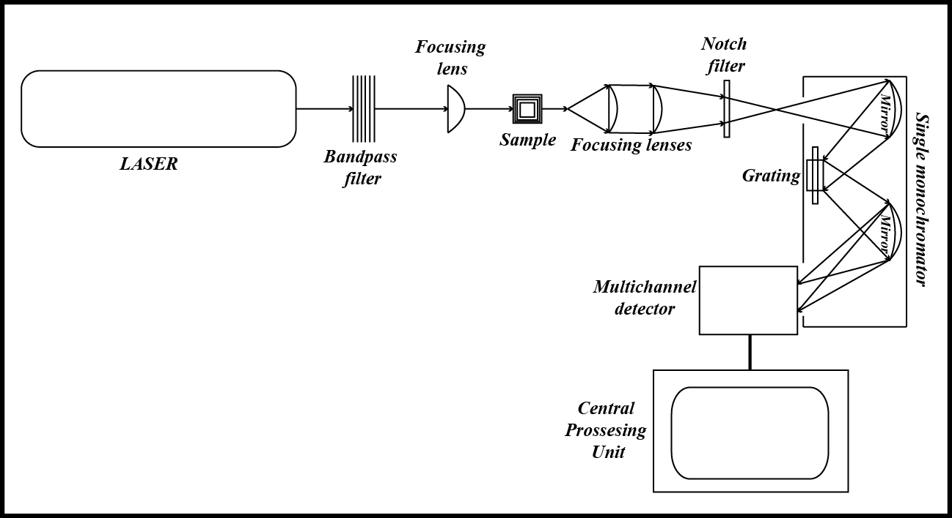
Raman scattering are acquired by blasting a sample with a powerful laser source of visible or close to infrared monochromatic radiation characteristics (figure 9). In comparison with other techniques that use spectra as Raman, there are some differences. As an example the fluorescence emission spectrum: this technique is rigors by the electronic transition frequencies of the molecule, which always occurs at the same frequency and does not matter the light frequency. In other hand, Raman has peculiar and different ways to operate; the spectrum is always shifted from the frequency of the excitation light by proportional energy, regardless of its frequency (Kneipp & Feld, 2008). Another difference with fluorescence is in time sensitive experiments. Raman can “handle” time sensitive experiments, while fluorescence cannot. That is why Raman scattering emission occurs at the same time as the excitation laser pulse whereas fluorescence occurs with some time delay, in order from picoseconds to microseconds (Kneipp & Feld, 2008). Because of this, Raman is considered value in determining molecular structure in chemical analysis. This technique is highly used in many fields, not only for it’s capacity to determine the chemical and structural composition of samples, but because the analysis could be applied to any molecules in liquid, gas phase, and solid samples.
Figure 9. Schematic diagram of the Raman spectroscopy
When a monochromatic light beam is hitting a sample, it does not matter if it is in a gas, liquid, or solid phase most of it is transmitted without a change yet some of the light is scattered. During irradiation, the spectrum of the scattered light is measured at some angle, which is commonly 90°, with a spectrometer (Skoog, Holler, & Crouch, Raman Spectroscopy, 2007). Is used a monochromatic beam of energy ${hv}_{ex}$, because the excitation from the light beam need to be away from an absorption band, that excitation should not be considered as an object out of the virtual state of the molecule, actually this is the condition to acquire the change in energy. This excitation is considered to involve the virtual state of energy level.
4.2 Sulfur applications
Raman spectrometry is a simple, reliable, and powerful technique that is used in many fields. This instrument has the capacity to relate the spectra disorder, size, and mechanical properties in materials (Gouadec & Colomban, 2007). Because Raman scattering happens instantaneously $\left(<{10}^{-14}sec.\right)$, this technique is reliable to use with intermediate compounds that exist in short-lived in some environments. Raman is capable to observe and analyze the short-live intermediate, for example elemental sulfur. Every instrument has it own limitation and disadvantages. For example when establishing the kinetic parameters of sulfoxyanions, Raman scattering intensity changes with molecule, this spectra does not offer an accurate analysis when concentration changes (Meyer, Ospina, & Peter, 1980). That is the accuracy of the Raman spectrometer that is used for the determination of the presence and the speciation of sulfur in chemoautotrophs. As an example in Monterrey Bay a group of scientist analyzed the speciation of sulfur in sulfur-oxidizing marine bacteria, which uses the energy derived from the oxidation of $H_{2}S, HS^{-}$, or$S_{2}{O_{3}}^{2-}$. In other words, Raman is a powerful technique that can “follow” the metabolic pathways of sulfur in a microbial cycling (Pasteris, Freeman, Goffredi, & Buck, 2001). Sulfur is already known for the instability that compounds suffer on electron beam, specifically when it is under a vacuum (Meyer B. , 1976), making sulfur compounds hard to analyze with techniques that involve those conditions. In addition, there are some concerns regarding the chemical speciation. This is the case when studying elemental sulfur (chains or rings) or sulfur organic compound, such as polythionates (Pasteris, Freeman, Goffredi, & Buck, 2001).
Raman has been recognized as a helpful in situ tool for identifying aqueous species and sometimes for the determination of equilibria on field research. Aqueous chemistry of polysulfide solutions is a complex task. The study of Raman spectra of the polysulfide anions in relation to their molecular structure, allows a better understanding of sulfur speciation using sulfur compounds, as an example sodium sulfide. This makes the identification of bands in the spectra just using S:Na ratios possible (Khan, Hughes, & Reynolds, 2011). Using the Raman scattering technique its possible to identify the presence of aqueous thiosulfate, sulfite, hydrogensulfite, disulfite, sulfur oxide, sulfate, hydrogensulfate, dithionate, dithionate and tetrathionate (Meyer, Ospina, & Peter, 1980). Raman can also be used in high temperature and pressure dependence conditions. Spectroscopic measurements are performed using Raman spectroscopy of the vibrational energy levels of orthorhombic sulfur (Eckert, Albert, Jodi, & Foggi, 1996). Raman is a wonderful technique in situ and in the laboratory, and can be used at different temperature and pressure environments (Eckert, Albert, Jodi, & Foggi, 1996; Becucci, Bini, & Castellucci, 1997; El Jaroudi, Picquenard, Gobeltz, Demortier, & Corset, 1999).

5. Voltammetry: An electrochemical technique
The definition in detail of an environment is one of the more complex tasks to solve in science. Complex environments are made of many paths, reactions, and different compounds, especially if other factor like geology, hydrology and, elevation are involved in the confection of this places. That is why defining an environment, as an undisturbed and natural one has been one of the goals and a challenge of many researches in geochemistry, including chemical speciation, microbial communities, and structural geology thru the past decades. The understanding of the following combinations as: temperature, differences in pH, biotic interactions, and the variation of the amount of oxidized and reduced chemical species is really helpful in order to weave a web of knowledge many abiotic and biotic interactions at different energy levels. That is why the utilization of electrochemical techniques will contribute to with minimal disruption in the analysis of these systems, this technique provide us a piece of the geochemical information available in environments where there is the presence of oxidized and reduced ions with just applying real-time in situ redox chemistry. Some of these combinations triggers many reactions which can be perceived by simple observation, but for some other exists the necessity to use more specialized instruments, in which by the utilization of different mechanisms and techniques make possible the detection and description of the different steps in the reaction. Some chemical reactions happen instantaneously, which means these are time-sensitive. A good example of these powerful techniques is voltammetry, which is based on the measurement of the current that exists in an electrochemical cell created by a polarization. Voltammetry, as an electrochemical technique involves precision on every measurement making possible the explanation of many time-sensitive reactions and their intermediate steps and compounds speciation. Voltammetry is a trusted and widely performed technique by physicists, geochemists, and biological chemists in order to describe and analyze many chemical reactions, in other words, with the objective to obtain analytical or fundamental information regarding electro-active species in solution (Brendel & Luther, 1995). These reactions include fundamental oxidation and reductions processes, absorption processes on surfaces, and inclusive the mechanisms of the electron transference in a chemically modified electrode surfaces (Skoog, Holler, & Crouch, Voltammetry, 2007; Fry, 2008). Coupled reactions are initiated by the production or depletion of the primary products or reactants found the sample at the electrode surface. The identification of the nature and mechanisms of such coupled reactions is really important in order to describe reactions in organic compounds, in which multi-reaction and multi-electron are abundant and initiated by electron transferring between the electrode and the electroactive solution and describe many physical-chemical phenomena by processes occurring at few micrometers to the electrode surface (Fry, 2008).
Voltammetry is a field that is preceded by polarography; invented by a Czechoslovakian chemist Jaroslav Heyrovsky on 1922 and the scientist who later won the Nobel Prize in chemistry on 1959 by his wonderful discovery (Herguth & Phillips). Since then voltammetry has been one of the principal electrochemical technique utilizes in many laboratories as a part of a regular process in experiments. Due to several discoveries and innovations in science at the middle 1960’s, classical voltammetry technique suffered drastically advantages creating a more powerful and significantly sensitive modern voltammetry technique, making this technique more powerful to in-situ analysis around of many specific and unique environments.
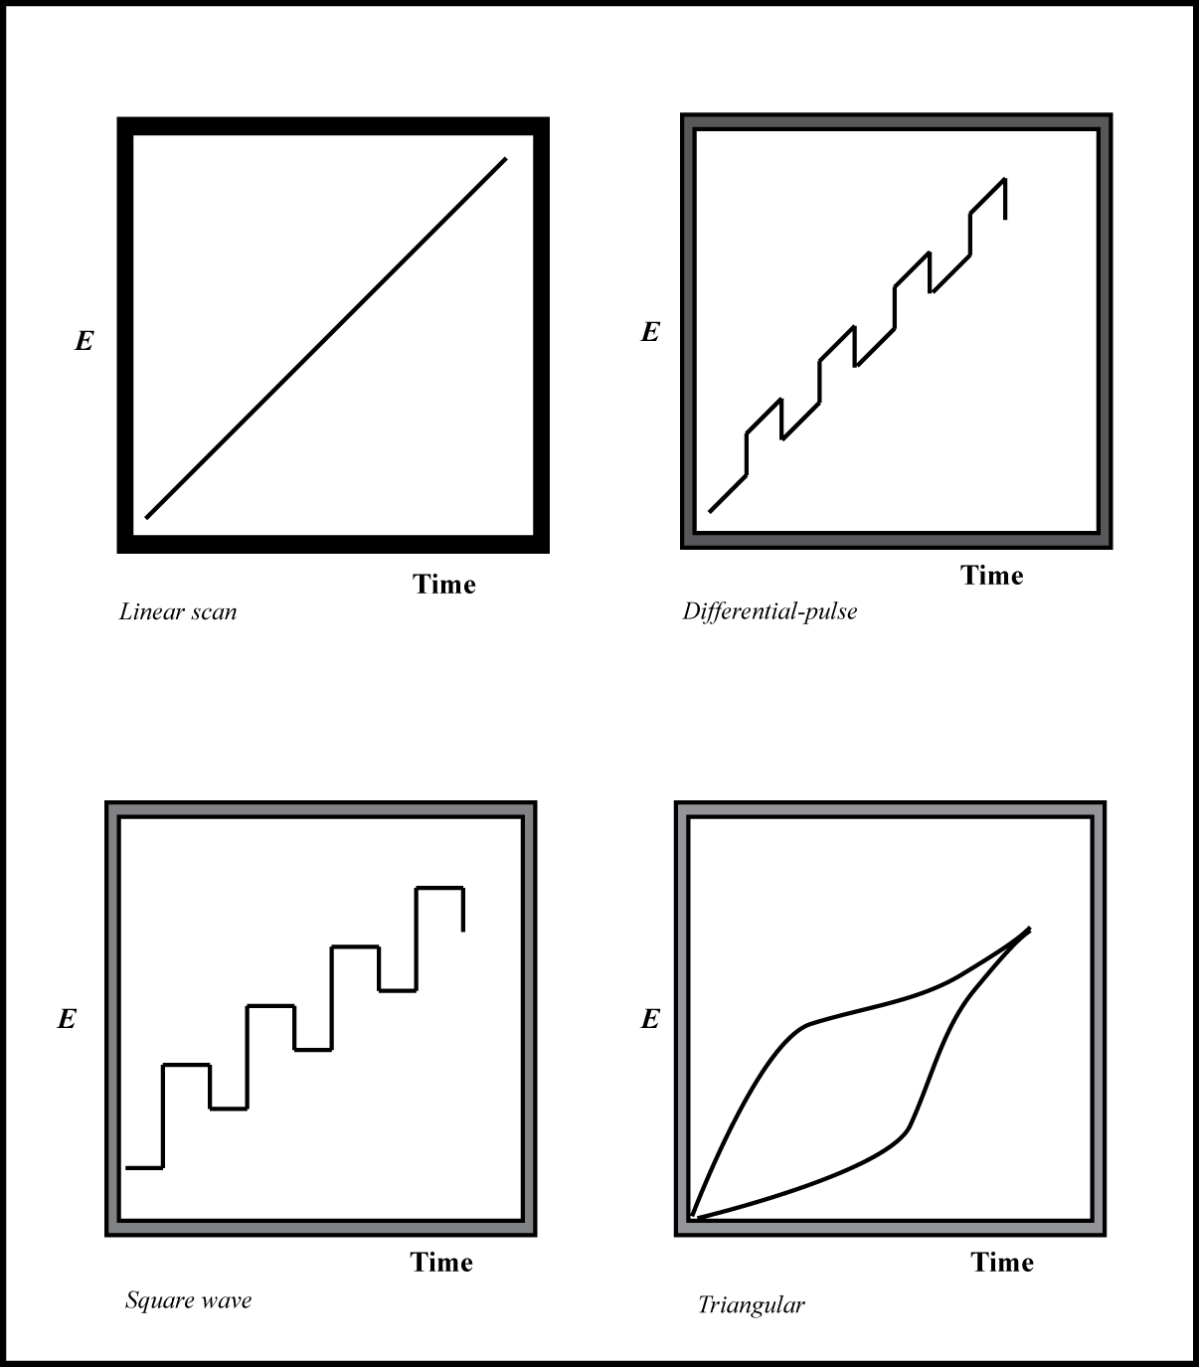
Voltammetry can be observed as an excitation signal (figure 10), in which the voltage is applied to a cell and this signal increase as a function of time. The current applied to the cell is recorded as a function of time and this function as one of applied voltage (Skoog, Holler, & Crouch, Voltammetry, 2007). In voltammetry, the result of the changing in excitation on the potential is impressed on a working electrode in an electrochemical cell. There is the possibility to change the potential in order to create different scans, and using others working electrodes, in comparison with polarography, which is unique and necessary the utilization of a mercury drop-working electrode. The primary experimental variables in electrochemical analysis are established by the definition on every experiment of the potential (E), current (I), and the time (t). The potential or current applied at the working electrode is controlled and the other is observed as a function of time. This, making possible the control and conduct many combinations of controlled-potential or controlled-current analysis techniques as a function of time (Fry, 2008). We can express the mathematical relationship between E, I, and t on the electrochemical analysis as a integration circuit, in which for a constant dc input potential of E_{i}, the output potential E_{o} is described by:
Figure 10. Voltage Vs. time excitation signals used in voltammetry.
$$E_{o}=-\frac{E_{t}}{R_{i}C_{f}}\int_{0}^{t}{dt}$$
in which the potential output will be the product of the current in circuit. The potential a specific time is inversely proportional to the resistance and the capacitor applied on the electrochemical analysis as a function of a differential in time. The resistance in the capacitor changes by the operation of switches in the system, creating different types of resistance. When the reset switch is open and the hold switch is closed, the capacitor begins to charge. Knowing that there is a relationship between current and the capacitor, we can expressed that function as the following relationship:
$$i_{f}=-C\frac{dv_{o}}{dt}$$
from Ohm’s law the current i_{i} is given by:
$$i_{i}=\frac{dv_{o}}{dt}$$
thus may write:
$$dv_{o}=-\frac{v_{i}}{R_{i}C}dt$$
$$R_{i}=-\frac{V_{i}}{dV_{o}C}dt$$
$$\int_{0}^{t}{R_{i}=-\frac{1}{dv_{o}C}} \int_{o}^{t}{v_{i}dt}$$
this relationship describes how the resistance, differential in potential, and the capacitor work together to produce a signal in which will be the summatory of this relationship per time. The entire current from the source is carried from the counter electrode to the working electrode. In addition, the control circuit has the capacity to adjust the current applied making the difference in potential between the electrodes, working and reference, be identical to the output voltage from the voltage generator (Protti, 2001). In other words, the resulting current, which has a directly proportional relationship to the potential difference between the working electrode-reference, is converted to a voltage and recorded as a function of time by the acquisition instrument.
5.1 Instrumentation
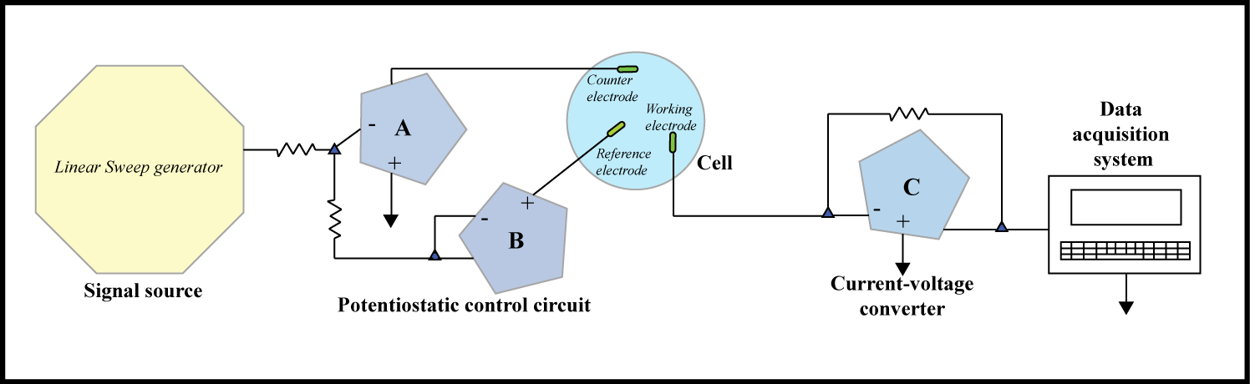
Voltammetry is a combination of electroanalytical methods in which the data of the analyte is acquired by quantifying current as a function of the applied potential under conditions that encourage polarization of a working electrode (Protti, 2001; Kounaves, 2010; Batina, Ciglenecki, & Cosovic, 1992). The instrumentation (figure 11) that is required to perform the analysis is a combination of three (3) electrodes and an acquisition instrument working as a system. The electroanalytical cell as a part of the voltammetry system, consist in three electrodes immersed in a solution which contain the analyte and also and excess of a non-reactive electrolyte, as an example saturated KCl solution. First, the reference electrode that commonly consists in a silver-silver chloride electrode; in which the potential remains constant thru the experiment. Next, the counter electrode is often a coil of platinum wire that simply conducts electricity coming from the source through the solution to the working electrode. Finally, the working electrode, in where the potential is varied thru time, and its dimensions are small to enhance the tendency to become polarized (Kounaves, 2010).
Figure 11. An operational amplifier potentiostat. The three-electrode cell is composed by a working electrode, counter electrode, and a reference electrode.
5.1.1 Working electrodes

The working electrodes used in voltammetry techniques, varies depending the precision and what compounds have been examined on different environments. They can vary in shapes and forms, but commonly is a cylinder with a small flat end. A conductor is press fitted into a thin straight bar of an inert material, such as Teflon. This inert material has embedded in the contact, which is a wire (image 2). This conductor could be a noble metal, such as platinum or gold; a carbon material, like carbon paste, carbon fiber, glassy carbon, diamond, or inclusive carbon nanotubes; a semiconductor, such as Sn (tin) or $\ln_{2}O_{3}$ (indium oxide); or mercury.
Image 2. Metal working electrode.
5.1.2 Mercury electrode
Mercury specially has been commonly used in voltammetry for the capacity to have a fresh surface every time during the analysis among other reasons. As an example, Mercury working electrode has a relatively large negative potential range. Sometimes the positive potential limitations are caused by the current product of the oxidation of the water to give molecular oxygen. This negative potential increase with the reduction of water to produce hydrogen, but is really well tolerated by the mercury working electrodes because the overvoltage of the hydrogen on the noble metal. Mercury has become one of the most reliable working electrodes in the voltammetry technique, because having a fresh drop every time means a fresh metallic surface to induce the chemical reactions necessary to identify the compounds present in the sample. This is equivalent to do not have scratch surfaces like in the other working electrodes, always having a fresh surface thru the time of the experiment in order to have better and reliable results of the chemical reactions where are happening on that surface. This ability to have a fresh drop every time is really important from the perspective that the current measured in voltammetry are quite sensitive to cleanliness and irregularities on the surface of the working electrode (Skoog, Holler, & Crouch, Voltammetry, 2007). HDME (Hanging Drop Mercury Electrode) is an example of a working electrode with the capacity to create a fresh drop of mercury (figure 12). This mercury electrode consists in a very fine capillarity cylinder connected to a mercury-containing reservoir, in which the metal is stimulated out of the capillarity by a piston. This piston permits the formation of fresh drops, having surface areas that are reproducible to 5% or better.
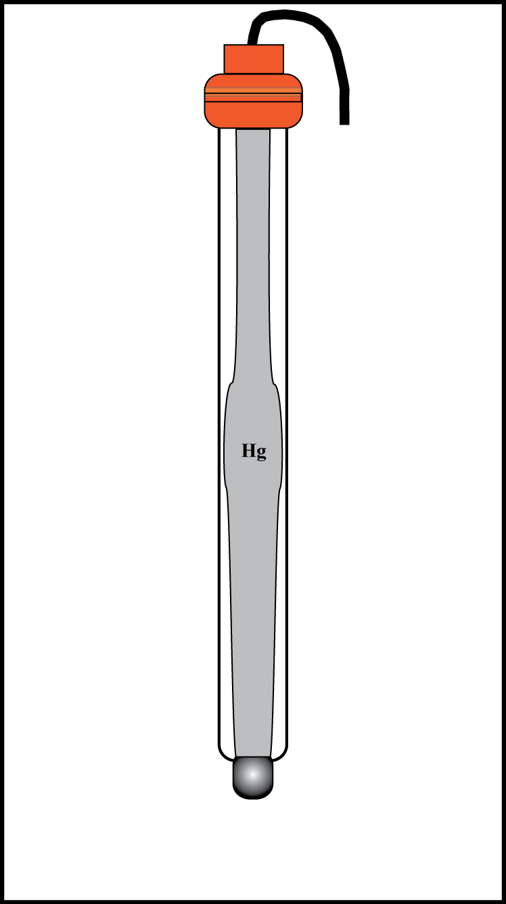
5.2 Voltammetry applications in Sulfur
Figure 12. Hanging Mercury Drop Electrode (HMDE)
Voltammetry is a technique that is trustfully used by many scientists who are related in one way or another with sulfur and other chemical compounds in aqueous systems. As an example linear voltammetry is used for the quantitative determination of a wide variety of many inorganic species, which includes molecules of biological and non-biological interest (Skoog, Holler, & Crouch, Voltammetry, 2007). This electrochemical technique is a reliable technique for compounds that are time-sensitive like elemental sulfur. Elemental sulfur (S⁰) is formed during the biotic and abiotic oxidation of dissolved sulfide and solid metal monosulfide (Wang, Tessier, & Buffle, 1998; Meyer B. , 1976). Also, elemental sulfur has really low solubility in water but its solubility can be significantly increased when is found on sulfidic waters, reacting with dissolved sulfide to form polysulfide species. Electrochemical analysis methods that are commonly used in sulfur speciation, which includes differential-pulse polarography, cathodic sweep voltammetry and normal polarography. This voltammetric techniques are not used only to know the concentration, but also give information about the identity, origin, distribution and behavior of sulfur species in natural water environments (Batina, Ciglenecki, & Cosovic, 1992). The alternate current (a.c.) voltammetry is widely used in aqueous environments like natural waters and effluents to study surface-active substances. In anoxic environments, the presence of sulfur is really well identified by a clear and defined peak, which increase with accumulation time. This valuable information provides how the reaction proceeds and how many steps are taking to the reaction to be completed (Merritt & Sawyer, 1970).
There are available specific voltammetric techniques for specific environments or systems, as an example Differential Pulse Polarography (DPP) method, which in the literature is categorized as the most efficient and convenient for pore waters. This technique just requires small volumes (2-5mL) of sample. This volume is enough to acquire an acceptable detection limit. Because voltammetry techniques is a good method to take advantage of the selectivity, sensitivity, accuracy, and less volume for sample, some scientist have suggested some voltammetric techniques to analyze elemental sulfur. As an example, Batina et al. 1992 proposed that dissolved elemental sulfur could be analyzed and estimated by phase-sensitive a.c. voltammetry using the information from the ratio of anodic to cathodic currents. The research group stipulated that this technique was capable to determining simultaneously dissolved sulfide and elemental sulfur without alternate the sample (Wang, Tessier, & Buffle, 1998). Keeping this path of taking advantage of voltammetry techniques to try to understand better the nature of elemental sulfur, Buffle et al., (1987) suggested that is was possible to measuring dissolved elemental sulfur by cathodic sweep voltammetry after a process of acidification and purging of the sample with an inert gas in order to remove all possible sulfide from the experiment; as a result they reported that it was necessary to add ethanol to the water sample to maintain the elemental sulfur in it dissolved form on the solution. These 20 years old experiments were just the pioneers in trying to understand why sulfur compounds are so unique for analysis. That is why modern techniques have been created to explain some natural phenomena of sulfur using other techniques and parameters. Modern polarographic techniques have been a good example to determinate sulfur species in a wide variety of different samples such as natural lake waters, hydrothermal pools, and other environments that have become anoxic thanks to microbial activity. Some electrochemical methods like differential-pulse polarography, cathodic sweep voltammetry and normal-pulse polarography, in combination with other spectroscopic techniques have been a really good combination in order to acquire other information as distribution and behavior of sulfur species in natural water systems. This is because the principle of this procedure is based on a two-electron reversible electrochemical process, which involves the oxidation of mercury (II) to mercury (III) ions with immediate formation of insoluble mercury (II) sulfide at the working electrode surface (Skoog, Holler, & Crouch, Voltammetry, 2007). For a time-sensitive and no-need of pretreatment technique, some researchers use the square-wave voltammetry, which provides a fairly analysis in seconds. This technique is high sensitive and is used in a wide range of application for sulfur compounds, because does not required big sample sizes some environments are not disturbed after an electrochemical analysis (Wandruszka, Yuan, & Morra, 1993). Also, some anodic reactions of sulfide, sulfite, and thiosulfate have been examined and in general E_{1/2} the values are dependent on the pH of the composition that are supporting the electrolyte. This entire resume is an example that is just a small proof of what applications are useful voltammetry. After the discovery of this technique there is big diversity of applications in many branches of science including, biology, geology, chemistry, inclusive engineering. This technique results to be a good complement in combination with other techniques in order to describe, determine and analyze systems in which other techniques have no successful progress.

Literature cited

- Eckert, B., Albert, H. O., Jodi, H. J., & Foggi, P. (1996). Raman studies of Sulfur Crystal (α-S8) at High Pressures and Low Temperatures. Journal of Physical Chemistry , 8212-8219.
- Becucci, M., Bini, R., & Castellucci, E. (1997). Mode Assignment of Sulfur α-S8 by Polarized Raman and FTIR Studies at Low Temperatures. Journal of Physical Chemistry , 2132-2137.
- Waldron, R. D. (2008). Dipole moment. Retrieved July 21, 2011, from AccessScience: http://www.accessscience.com.ezproxy.uvm.edu/content/Dipole%20moment/198500
- Wandruszka, R. V., Yuan, X., & Morra, M. J. (1993). Determination of sulfur species by cathodic square wave stripping voltammetry; compounds relevant to natual sulfur mineralization. Talanta , 37-42.
- Wang, F., Tessier, A., & Buffle, J. (1998). Voltammetric determination of elemental sulfur in pore waters. Limnology Oceanography , 1353-1361.
- Wedd, M. (2005). Particle Size Analysis. Encyclopedia of analytical science , 18-29.
- Van Duyne, R. P., & Haynes, C. L. (2004). Raman Spectroscopy. In Encyclopedia of Physical Science and Technology. Elsevier.
- Buffle, J., Zali, O., Zumstein, J., & de Vitre, R. (1987). Environmental Science Technology. (64), 41.
- Batina, N., Ciglenecki, I., & Cosovic, B. (1992). Determination of elemental sulphur, sulphide and their mixtures in electrolyte solutions. Analytica Chimica , 157-160.
- Beckman Coulter Inc. (2010). Coultercounter. Retrieved 2011 йил 20-February from http://www.beckmancoulter.com/coultercounter/product_delsaNano.jsp
- Bertram, W. E., & Lawrence, D. F. (2008). X-ray diffraction. (McGraw-Hill Companies) Retrieved from AccessScience: http://www.accessscience.com
- Black, J. T. (1974). The Scanning Electron Microscope: Operating Principles. In M. A. Hayat, Principles and Techniques of Scanning Electron Microscopy (pp. 1-43). New York: Van Nostrand Reinhold Company.
- Bonard, J.-M., Dean, K. A., Coll, B. F., & Klinke, C. (2002). Field Emission of Individual Carbon Nanotubes in the Scanning Electron Microscope. The American Physical Society , 197602.1 - 197602.4.
- Brügermann, L., & Gerndt, E. K. (2004). Detectors for X-ray diffraction and scattering: a user's overview. Nuclear Instruments and Methods in Physics Research (531), 292-301.
- Brendel, P. J., & Luther, G. W. (1995). Development of a Gold Amalgam Voltammetric Microelectrode for the Determination of Dissolved Fe, Mn, O2, and S(-II) in Porewaters of Marine and Freshwater Sediments. Environmental Science and Technology , 29 (3), 751-761.
- Cullity, B. D., & Stock, S. R. (2001). Elements of X-Ray Diffraction. Upper Saddle River: Prentice Hall.
- Edwards, H. G., Farwell, D. W., Turner, J. M., & Williams, A. C. (1997). Novel Environmental Control Chamber for FT-Raman Spectroscopy: Study of in situ Phase Change of Sulfur. Society for Applied Spectroscopy , 51 (1), 101-107.
- Einstein, A. (1905). Über die von der molekularkinetischen Theorie der Würme gefordete Bewegung von in ruhenden flüussigkeiten suspendierten Teilchen. Annnalen der Physik , 549-560.
- El Jaroudi, O., Picquenard, E., Gobeltz, N., Demortier, A., & Corset, J. (1999). Raman Spectroscopy Study of the Reaction between Sodium Sulfide or Disulfide and Sulfur: Identity of the Species Formed in Solid and Liquid Phases. Inorganic Chemistry , 2917-2923.
- Dyar, M. D., Gunter, M. E., & Tasa, D. (2008). Diffraction. In M. E. Gunter, Mineralogy and Optical Mineralogy (pp. 363-401). Chantilly: Mineralogical Society of America.
- Dicken, A., Rogers , K., Evans, P., Rogers, J., & Chan, J. W. (2010). The separation of X-ray diffraction patterns for threat detection. Applied Radiation and Isotopes , 439-443.
- Fry, A. J. (2008). Electrochemical techniques. Retrieved August 17, 2011, from Accessscience: http://accessscience.com/content.aspx?searchStr=Electrochemical+techniques&id=220200
- Frisken, B. J. (2001). Revisiting the method of cumulants for the analysis of dynamic light-scattering data. Optical Society of America , 4087-4091.
- Gouadec, G., & Colomban, P. (2007). Raman Spectroscopy of nanomaterials: How spectra relate to disorder, particle size and mechanical properties. Progress in Crystal Growth and Characterization of Materials , 1-56.
- Hayes, T. L. (2008). Scanning electron microscope. Retrieved 07 2011, from AccessScience: http://www.accessscience.com
- Hatfield, R. G., & Maher, B. A. (2009). Fingerprinting upland sediment sources: particle size-specific magnetic likages between soils, lake sediments and suspended sediments. Earth surface processes and landforms (34), 1359-1373.
- Herguth, W. R., & Phillips, S. Comparison of common analytical techniques to voltammetric analysis of antioxidants in industrial lubricating oils. STLE Annual Meeting, (pp. 1-9). Kansas city.
- Holoubek, J. (2007). Some applications of light scattering in materials science. Journal of Quantitative Spectroscopy & Radiative Transfer , 104-121.
- Honjo, S., & Berggren, W. A. (1967). Scanning Electron Microscopy of Planktonic Foraminifera. The Micropaleontology Project, Inc. , 393-406.
- Kimura, H., Tamura, H., Higuchi, H., & Maki, M. (1969). Patent No. 3,474,245. USA.
- Khan, S. A., Hughes, R. W., & Reynolds, P. A. (2011). Raman spectroscopic determination of oxoanions in aqueous polysulfide electrolyte solutions. Vibrational Spectroscopy , 241-244.
- Kneipp, K., & Feld, M. S. (2008). Raman effect. Retrieved July 21, 2011, from AccessScience: http://www.accessscience.com.ezproxy.uvm.edu/content.aspx?searchStr=Raman+effect&id=572400
- Kounaves, S. P. (2010). Voltammetric Techniques. In Handbook of Instrumental Techniques for Analytical Chemistry. Tufts University.
- Koppel, D. E. (1972). Analysis of Macromolecular Polydispersity in Intensity Correlation Spectroscopy: The Method of Cumulants. The Journal of Chemical Physics , 4814-4820.
- Lorenson, G. W. (2006). APPLICATION OF IN SITU AU-AMALGAM MICROELECTRODES IN YELLOWSTONE NATIONAL PARK TO GUIDE MICROBIAL SAMPLING: AN INVESTIGATION INTO ARSENITE AND POLYSULFIDE DETECTION TO DEFINE MICROBIAL HABITATS. The University of Vermont, Department of Geology. Burlington: Graduate College.
- Meyer, B. (1976). Elemental Sulfur. Chemical Reviews , 76 (3), 1976.
- Meyer, B., Ospina, M., & Peter, B. (1980). Raman spectrometric determination of oxysulfur anions in aqueous systems. Analytica Chimica Acta , 301-311.
- Merritt, M. V., & Sawyer, D. T. (1970). Electrochemical Reduction of Elemental Sulfur in Aprotic Solvents. Formation of a Stable S(8)-Species. University of California, Department of Chemistry.
- Moore, J., & Cerasoli, E. (2010). Particle Light Scattering Methods and Applications. Encyclopedia of spectroscopy and spectrometry , 2077-2088.
- Pasteris, J. D., Freeman, J. J., Goffredi, S. K., & Buck, K. R. (2001). Raman spectroscopic and laser scanning confocal microscopic analysis of sulfur in living sulfur-precipitating marine bacteria. Chemical Geology , 3-18.
- Pecora, R. (2000). Dynamic light scattering measurement of nanometer particles in liquids. Journal of Nanoparticle Research , 123-131.
- Protti, P. (2001). Introduction to Modern Voltammetric and Polarographic Analysis Techniques. (IV).
- Singh, R. (2002). C. V. Raman and the Discovery of the Raman Effect. Physics in Perspective , 399-420.
- Skoog, D. A., Holler, F. J., & Crouch, S. R. (2007). Voltammetry. In D. A. Skoog, F. J. Holler, & S. R. Crouch, Principles of Instrumental Analysis (pp. 716-760). David Harris.
- Skoog, D. A., Holler, F. J., & Crouch, S. R. (2007). Raman Spectroscopy. In D. A. Skoog, F. J. Holler, S. R. Crouch, & S. Kiselica (Ed.), Principles of Instrumental Analysis (pp. 481-497). Belmont, California, USA: Thomson Higher Education.
- Splinter, D. K., Dauwalter, D. C., Marston, R. A., & Fisher, W. L. (2010). Ecoregions and stream morphology in eastern Oklahoma. (122), pp. 117-128.
- Reimer, L. (1998). Scanning Electron Microscopy: Physics of image formation and microanalysis (2nd Edition ed.). (P. W. Hawkes, Ed.) Berlin: Springer.
- Todokoro, H., & Ezumi, M. (1996). Patent No. 5,872,358. USA.

